Sydney Marie Clute
Class of 2012

2704 S Old St Rd 37
Greenwood IN 46143
317-422-1188
sydneyclute12@aol.com
www.sydneyclute.com

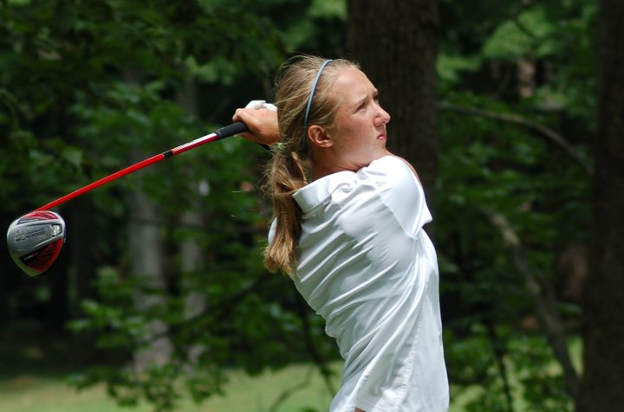
Profile
Height: 5'7"
Weight: 127 lbs
Date of Birth: 11/15/93
Right Handed
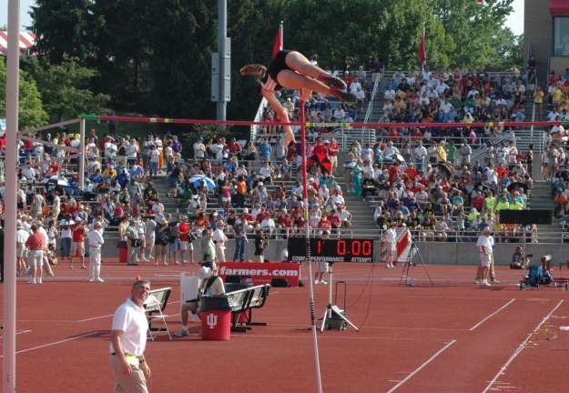
Academics
Center Grove High School
Graduation: May 2012
Current GPA: 3.96 Class Rank: 5/550
Weighted GPA: 4.52 Weighted Rank: 8/550
ACT Score: 32 SAT Score: 1900

Other Activities
National Honor Society
National Spanish Honor Society
Student Council Committee Chair
Varsity Gymnastics 2008 & 2009
People to People Student Ambassador

Golf Information
Coaches
Roger Lundy
Swing Coach
2007-Present
rlundy@indianagolf.org

Jim Williams
High School Coach
2008-Present
williamsj@centergrove.k12.in.us

Marty Mills
Strength and Conditioning Coach
2008-Present
millsm@centergrove.k12.in.us
www.centergroveschoolofstrength.blogspot.com

Honors 2008
All County

Honors 2009
All County Medalist
All Metropolitan Interscholastic Conference (MIC)
Team MVP

Honors 2010
Indiana Golf Foundation Player Points Champion
All County
18-Hole School Record Holder (66)
Chippendale GC Women Course Record (66)
All MIC team
Sectional Medalist
Team MVP

Competitive Results 2010
Indiana Golf Foundation 2010
DATE SCORE FINISH COURSE PAR YARDAGE RATING SLOPE

6/21-25 2 day qualifier 80, 85 Harrison Hills CC 72 5223 69.7 120
Won 1st match
Lost 2nd match

7/1-2 84, 77 5th/20 Swan Lake GC 72 5479 65.9 114

7/6-7 84 Cut first day Honeywell GC 71 5812 68.6 119

7/23 73 2nd/13 Harrison Hills CC 72 5223 69.7 120

Center Grove High School 2010

DATE SCORE FINISH COURSE PAR YARDAGE RATING SLOPE

8/2 73 4th/60 Battle Ground GC 72 5245 69.1 118

8/3 75 2nd/90 Covered Bridge GC 72 5943 74.6 129

8/4 79 6th/90 Smock GC 72 5264 66.8 112

8/5 78 4th/45 Foxcliff CC 72 5410 71.0 122

8/9 80 21st/105 Legends GC 72 5219 70.2 122

8/14 66 1st/90 Chippendale GC 72 5094 69.1 118

8/21 76 2nd/60 Smock GC 72 5264 66.8 112

8/28 78 3rd/30 Hickory Stick GC 71 4944 68.1 114

9/4 85 /105 Battle Ground GC 72 6002 68.2 118

9/11 79 5th/40 Oak Tree GC 73 4942 70.0 119
9/20 74 1st/70 Cascade GC 72 5008 67.8 112

9/25 87 /60 Foxcliff CC 72 5463 71.0 124

10/1-2 77-80 11th/ Legends of Indiana 72 5655 75.1 132

10/16-17 85-79 6th/36 Otter Creek CC 72 6100

Golf Playing Experience
Indiana Junior Mt. Dew Tour
PJGT

Track Information
Pole Vault Personal Record: 12' 6"
Long Jump Personal Record: 17'5.25"
Coaches
Kyle Walter
Pole Vault and Long Jump Coach
2009-Present
walterk@centergrove.k12.in.us

Wes Dodson
Head Girls Track Coach
2009-Present
dodsonw@centergrove.k12.in.us

Marty Mills
Strength and Conditioning Coach
2008-Present
millsm@centergrove.k12.in.us
www.centergroveschoolofstrength.blogspot.com

Honors 2009
All County High Jump and Long Jump
Team most versatile

Honors 2010
Indoor State Finals 5th in pole vault, 10'6"
County Champion Pole Vault and Long Jump
All Metropolitan Interscholastic Conference (MIC) Pole Vault
All MIC Champion Long Jump
Sectional pole vault record holder 11'1"
Regional pole vault record holder 11'6"
School pole vault record holder 12'
IHSAA State Finals 3rd in pole vault, 9th in long jump
Team MVP
IGSCA 2nd team all state

2009 Season
100 Meters
 |  |  | 13.84c |  | V F | Mar 24 | Ben Davis vs CG
200 Meters
 |  |  | 29.44c |  | V F | Mar 25 | Columbus North vs CG
 |  |  | 29.50a |  | V F | Apr 14 | Center Grove at Bloomington
400 Meters - Relay Split
 |  |  | 66.3 |  | V F | Mar 18 | CG JV Invite
 |  |  | 68.0 |  | V F | Apr 9 | Bloomington South vs CG
 |  |  | 69.0 |  | V F | Apr 14 | Center Grove at Bloomington
 |  | * | 64.4 |  | V F | Apr 21 | Johnson County Invitational
 |  |  | 64.4 |  | V F | May 1 | MIC Conference Meet
High Jump
 | 3 |  | 4' 10 |  | V F | Mar 24 | Ben Davis vs CG
 |  |  | 4' 8 |  | V F | Mar 25 | Columbus North vs CG
 |  |  | 4' 6 |  | V F | Apr 14 | Center Grove at Bloomington
 | 2 |  | 4' 6 |  | V F | Apr 16 | Warren Central JV Invitational
 | -- |  | NH |  | V F | Apr 18 | Midwest Prep Invitational.
 | 6 |  | 4' 8 |  | V F | Apr 21 | Johnson County Invitational
 |  |  | 4' 6 |  | V F | Apr 25 | North Central
Pole Vault
 | 2 |  | 7' 6 |  | V F | Apr 9 | Bloomington South vs CG
 | 1 |  | 7' 0 |  | V F | Apr 14 | Center Grove at Bloomington
 | 6 | * | 8' 0 |  | V F | May 1 | MIC Conference Meet
 | 3 |  | 8' 0 |  | V F | May 19 | IHSAA Girls Track and Field Sectionals
 | 4 | * | 9' 0 |  | V F | May 26 | IHSAA Girls Track and Field Regionals
Long Jump
 |  |  | 15' 2 |  | V F | Mar 18 | CG JV Invite
 | 3 | * | 16' 0.75 |  | V F | Mar 24 | Ben Davis vs CG
 | 2 |  | 15' 10.5 |  | V F | Mar 25 | Columbus North vs CG
 |  |  | 14' 5.5 |  | V F | Apr 9 | Bloomington South vs CG
 | 10 | * | 16' 8 |  | V F | Apr 18 | Midwest Prep Invitational
 | 1 |  | 16' 2.75 |  | V F | Apr 21 | Johnson County Invitational
 | 6 | * | 17' 2 |  | V F | Apr 25 | North Central
 | 5 |  | 17' 1 |  | V F | May 1 | MIC Conference Meet
 | 4 |  | 16' 8 |  | V F | May 19 | IHSAA Girls Track and Field Sectionals
 | 15 |  | 15' 5 |  | V F | May 26 | IHSAA Girls Track and Field Regionals
4x100 Relay
 | 1 |  | 54.04c |  | V F | Mar 25 | Columbus North vs CG
 | 3 |  | 51.59a |  | V F | Apr 25 | North Central
4x400 Relay
 |  |  | 4:42.0 |  | V F | Mar 24 | Ben Davis vs CG
 |  |  | 4:43.0 |  | V F | Apr 9 | Bloomington South vs CG
 |  |  | 4:33.9 |  | V F | Apr 14 | Center Grove at Bloomington
 | 1 |  | 4:18.55a |  | V F | Apr 21 | Johnson County Invitational
 | 6 |  | 4:18.54a |  | V F | May 1 | MIC Conference Meet

2010 Season
High Jump
 |  |  | 4' 10.00 |  |  |  |  | May 7 | Martinsville Relays
Pole Vault
 | 3rd |  | 9' 0.00 |  |  |  |  | Mar 13 | MidEast Meet
 | 5th | * | 10' 6.00 |  |  |  |  | Mar 20 | HSR Indoor Finals
 | 1st |  | 10' 0.00 |  |  |  |  | Mar 24 | Center Grove vs Columbus North
 | 2nd |  | 10' 0.00 |  |  |  |  | Apr 8 | Center Grove vs Bloomington South
 | 1st |  | 9' 0.00 |  |  |  |  | Apr 13 | Center Grove vs Bloomington North
 | 2nd |  | 10' 0.00 |  |  |  |  | Apr 17 | Midwest Prep Classic
 | 1st |  | 10' 0.00 |  |  |  |  | Apr 20 | Johnson County Track Meet
 | 2nd |  | 9' 6.00 |  |  |  |  | Apr 24 | North Central Invite
 | 3rd |  | 9' 6.00 |  |  |  |  | Apr 30 | MIC conference meet
 |  |  | 10' 6.00 |  |  |  |  | May 7 | Martinsville Relays
 | 1st | * | 11' 1.00 |  |  |  |  | May 18 | Columbus East Sectional
 | 1st | * | 11' 6.00 |  |  |  |  | May 25 | Shelbyville Regional
 | 3rd | * | 12' 0.00 |  |  |  |  | Jun 4 | IHSAA State Finals
Long Jump
 | 5th |  | 15' 7.50 |  |  |  |  | Mar 13 | MidEast Meet
 |  |  | 14' 11.00 |  |  |  |  | Mar 24 | Center Grove vs Columbus North
 | 1st | * | 16' 6.50 |  |  |  |  | Apr 8 | Center Grove vs Bloominton South
 | 1st |  | 16' 3.00 |  |  |  |  | Apr 13 | Center Grove vs Bloomington North
 | 8th | * | 16' 7.00 |  |  |  |  | Apr 17 | Midwest Prep Classic
 | 1st |  | 16' 6.00 |  |  |  |  | Apr 20 | Johnson County Track Meet
 | 3rd |  | 16' 1.25 |  |  |  |  | Apr 24 | North Central Invite
 | 1st | * | 17' 1.50 |  |  |  |  | Apr 30 | MIC conference meet
 |  |  | 15' 3.00 |  |  |  |  | May 7 | Martinsville Relays
 | 2nd |  | 16' 6.25 |  |  |  |  | May 18 | Columbus East Sectional
 | 2nd | * | 17' 5.25 |  |  |  |  | May 25 | Shelbyville Regional
 | 9th |  | 17' 4.00 |  | .2 |  |  | Jun 4 | IHSAA State Finals
4x100 Relay
 | 3rd |  | 51.14c |  |  |  |  | Apr 24 | North Central Invite
 | 5th |  | 50.19a |  |  |  |  | Apr 30 | MIC conference meet
 | 1st |  | 50.46a |  |  |  |  | May 18 | Columbus East Sectional
 | 2nd |  | 50.04a |  |  |  |  | May 25 | Shelbyville Regional
 | 16th |  | 49.78a |  |  |  |  | Jun 4 | IHSAA State Finals
2011 Indoor Season
55 Meter Dash
 | 7 |  | 7.85a |  | V P | Mar 12 | Mideast Indoor Classic
 | 7 | * | 7.81a |  | V F | Mar 12 | Mideast Indoor Classic
Pole Vault
 | 1 |  | 11' 11.00 |  | V F | Feb 12 | Indiana Track Club HS ...
 | 1 | * | 12' 0.00 |  | V F | Mar 4 | MIC Indoor
 | 1 | * | 12' 4.00 |  | V F | Mar 12 | Mideast Indoor Classic
 | 1 | * | 12' 6.00 |  | V F | Mar 19 | HSR Finals
Long Jump
 | 1 |  | 16' 8.00 |  | V F | Mar 4 | MIC Indoor
 | 3 |  | 16' 4.00 |  | V F | Mar 12 | Mideast Indoor Classic
 | 10 |  | 16' 1.50 |  | V P | Mar 19 | HSR Finals

2011 Outdoor Season
100 Meters
 | 2nd |  | 13.04c |  |  | V F | Apr 7
Pole Vault
 | 1st |  | 11' 0.00 |  |  | V F | Mar 23
 | 2nd |  | 11' 0.00 |  |  | V F | Apr 7 | Bloomington South vs. ...
 | 1st | * | 11' 6.00 |  |  | V F | Apr 20 | Johnson County Meet
 | --- |  | NH |  |  | V F | Apr 23 | North Central Invite
 | 1 |  | 9' 0.00 |  |  | V F | May 17 | IHSAA Sectional - Colu...
 | 1 | * | 11' 9.00 |  |  | V F | May 24 | Ihsaa Regional
 | 10 |  | 11' 3.00 |  |  | V F | Jun 4 | IHSAA State Finals (Gi...
Long Jump
 | 1st |  | 16' 6.50 |  |  | V F | Apr 7 | Bloomington South vs. ...
 | 1st | * | 16' 9.75 |  |  | V F | Apr 20 | Johnson County Meet
 | --- |  | ND |  |  | V F | Apr 23 | North Central Invite
4x100 Relay
 | 1st |  | 51.74c |  |  | V F | Mar 23 | Center Grove vs. colum...
 | 1st |  | 52.34c |  |  | V F | Apr 7 | Bloomington South vs. ...
 | 2nd |  | 52.14c |  |  | V F | Apr 20 | Johnson County Meet
 | 2 |  | 51.14c |  |  | V F | Apr 23 | North Central Invite
 | 4 |  | 51.74a |  |  | V F | Apr 29 | Metropolitan Interscho...

